**Customer Complaints Dashboard Adjustments**

WERE VINCENT PROJECT

**VISUALIZATIONS**

**Introduction**

This report leverages Tableau visualizations to analyze customer complaint data, providing insights into trends, patterns, and root causes. By examining the stacked bar chart, line chart, and treemap, we aim to improve decision-making, identify opportunities, and mitigate risks. The stacked bar chart breaks down complaints by product category and measure, highlighting areas of concern. The line chart visualizes the trend of complaints over time, identifying seasonal patterns or sudden spikes. The treemap shows the distribution of complaints across product categories and subcategories, highlighting high-complaint areas.

Through these visualizations, we can prioritize products with high complaint volumes, identify areas for process improvement, and monitor complaint trends to detect potential issues early on. By leveraging these insights, organizations can make data-driven decisions to enhance customer satisfaction and operational efficiency.

**First Visualization**

**Title: Complaint Distribution by Product and Measure**

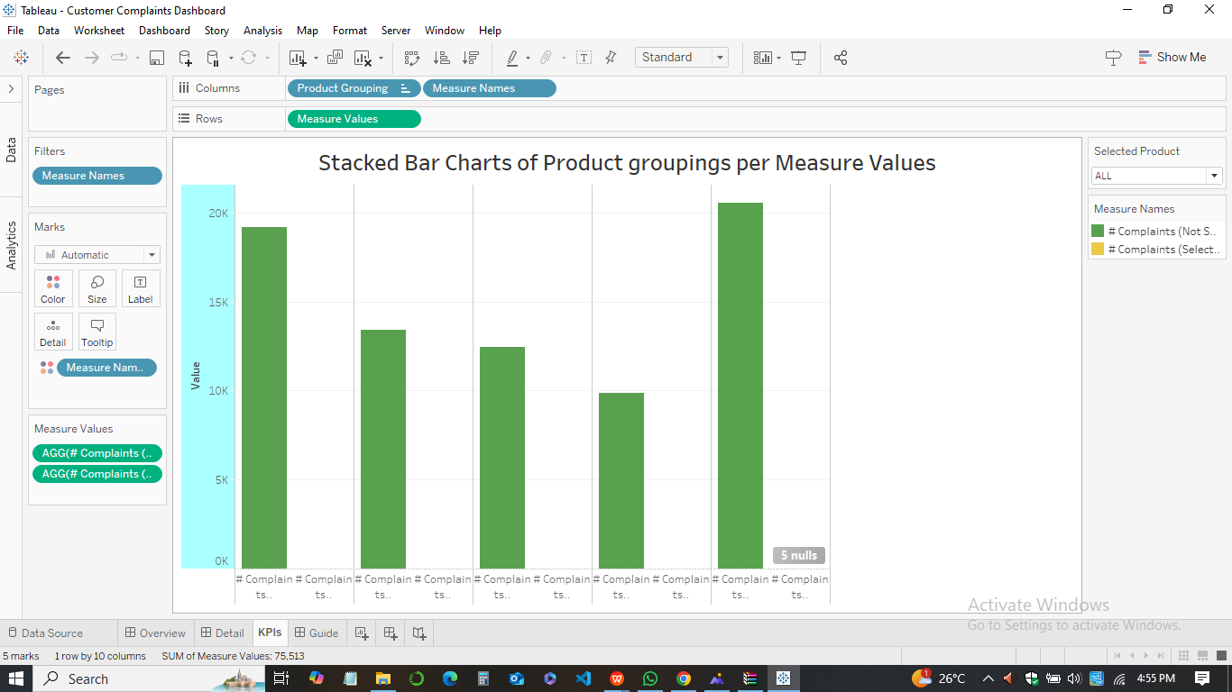

***Brief Analysis***

This stacked bar chart provides a visual representation of the distribution of complaints across different product groupings, categorized by specific measures. The height of each bar represents the total number of complaints for a particular product grouping, while the different colors within each bar indicate the proportion of complaints attributed to each measure.

***Critical Analysis:***

1. **Decision-Making**

* *Prioritization -* The chart highlights product groupings with the highest number of complaints, enabling focused attention and resource allocation.
* *Measure-Level Analysis -* By breaking down complaints into specific measures, it allows for a granular understanding of the underlying issues.
* *Comparative Analysis -* The chart facilitates comparison between different product groupings, helping identify potential trends and patterns.



1. **Opportunities**
2. *Product Improvement:* The chart can help identify product groupings with high complaint volumes, indicating areas for design or functionality enhancements.
3. *Process Optimization:* By analyzing the distribution of complaints across measures, it can reveal potential bottlenecks or inefficiencies in processes.
4. *Customer Experience Enhancement:* The chart can help identify specific measures that contribute significantly to customer dissatisfaction, enabling targeted improvements.
5. **Risk Mitigation**

* *Early Warning Signs -*  By monitoring complaint trends and identifying sudden spikes, the chart can help detect potential issues early on.
* *Proactive Measures -* It allows for proactive steps to be taken to address potential risks and prevent future complaints.
* *Risk Assessment -* The chart can help assess the relative risk associated with different product groupings and measures.

In sum, the stacked bar chart provides valuable insights into the distribution of complaints across product groupings and measures, empowering data-driven decision-making and risk mitigation strategies.

**Second Visualization**

**Analysis of the Line Chart: Trend on the Number of Complaints per Year**

**Title: Complaint Trend Over Time**

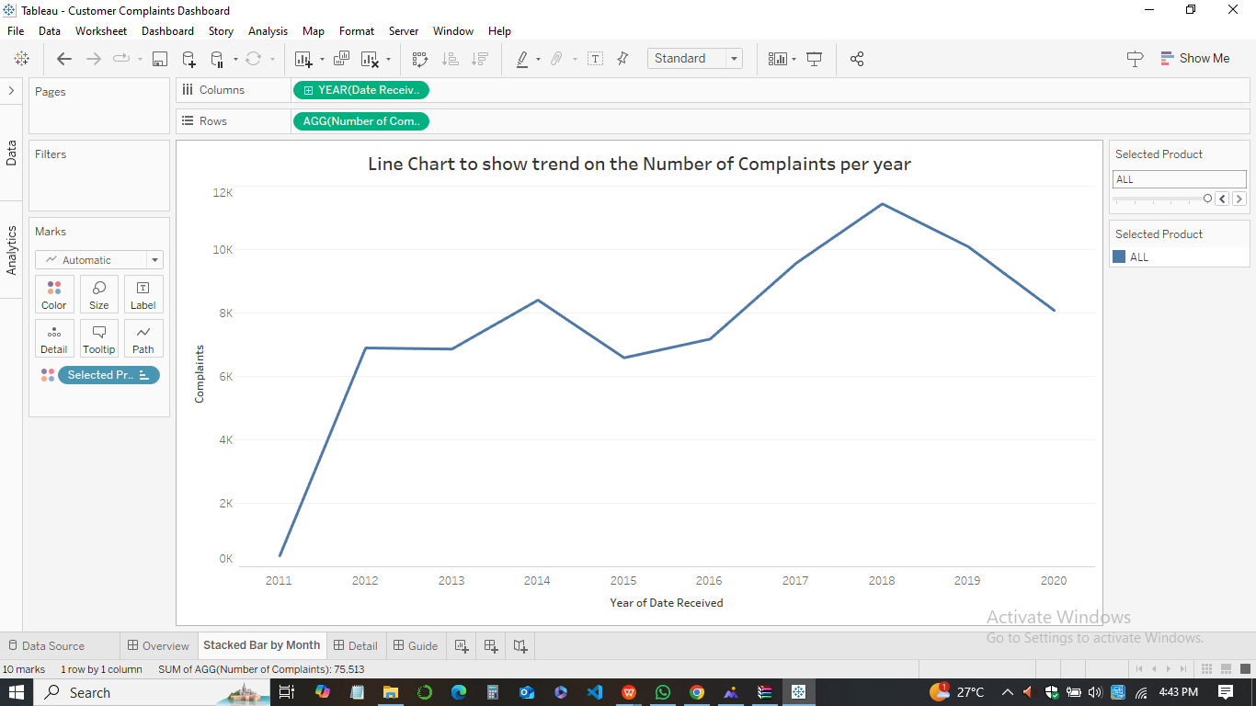

***Brief Analysis***

This line chart visualizes the number of complaints received over a period of several years. It provides a clear overview of the trend in complaints, highlighting periods of increase, decrease, or stability.

***Critical Analysis***



1. **Decision-Making**

* *Trend Identification -* The chart helps identify upward or downward trends in complaints, enabling timely intervention and resource allocation.
* *Seasonal Patterns -* It can reveal seasonal variations in complaints, allowing for proactive planning and resource management.
* *Benchmarking -* The chart can be used to compare complaint trends with industry benchmarks or historical performance.

1. **Opportunities**
2. *Process Improvement -* By identifying periods of increased complaints, the chart can help pinpoint areas where process improvements or additional training might be necessary.
3. *Customer Satisfaction -* Analyzing the trend can help assess the overall customer satisfaction level and identify areas for improvement.
4. *Resource Allocation -* The chart can inform resource allocation decisions, ensuring that adequate resources are available during peak complaint periods.

* **Risk Mitigation**
* *Early Warning Signs -* By monitoring the trend, the chart can help identify potential issues or risks before they escalate.
* *Proactive Measures -* It allows for proactive steps to be taken to address potential issues and prevent future complaints.
* *Contingency Planning -* The chart can help in developing contingency plans to handle potential spikes in complaints.

In conclusion, the line chart provides a valuable tool for understanding the dynamics of complaints over time, enabling data-driven decision-making and risk mitigation strategies.

**Third Visualization**

**Analysis of the Treemap - Product & Complaints**

**Title: Complaint Distribution by Product and Category**

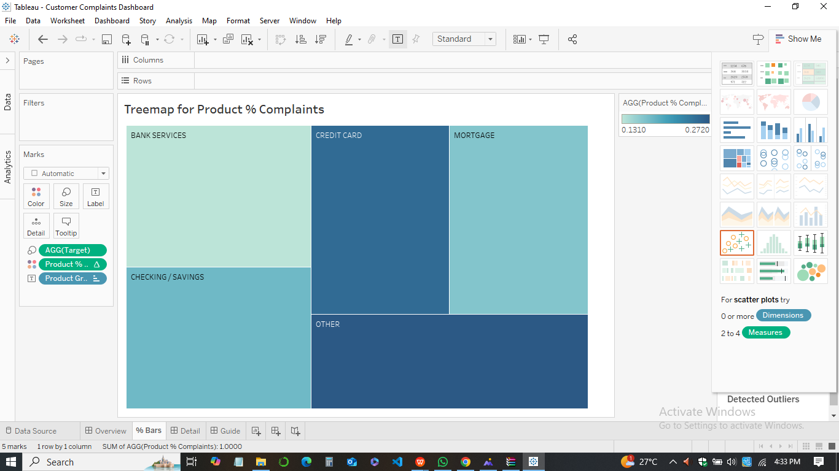

***Brief Analysis***

This treemap visualizes the distribution of complaints across different product categories and their subcategories. The size of each rectangle represents the number of complaints, while the color represents the product category.

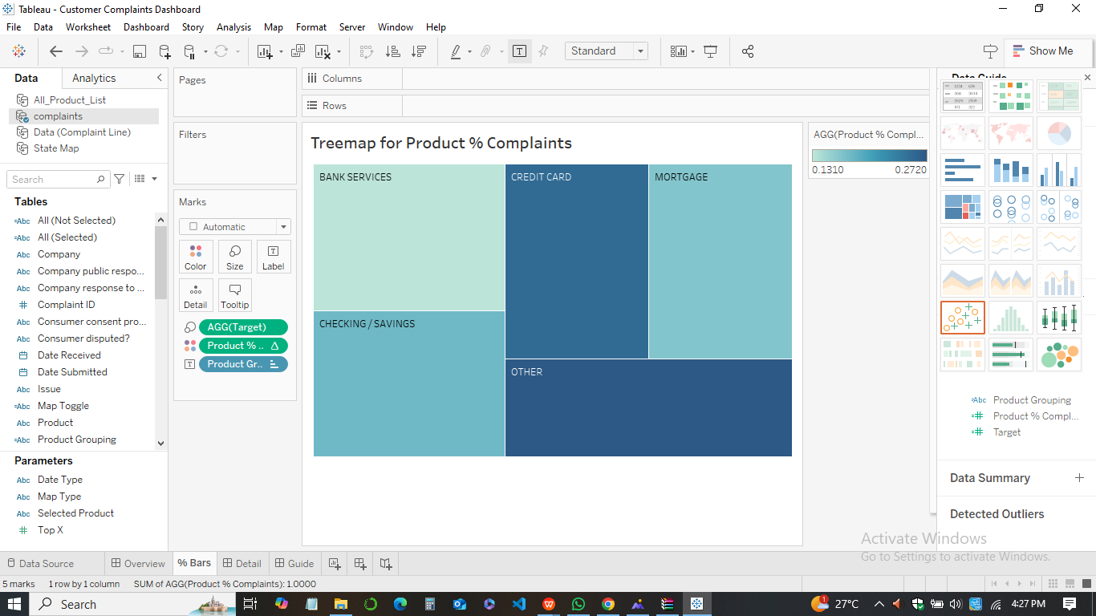

***Critical Analysis***

* **Decision-Making**

1. *Prioritization -* The treemap identifies product categories and subcategories with the highest number of complaints, enabling focused attention and resource allocation.
2. *Hierarchical View -* It provides a hierarchical view of complaint data, allowing for a deeper understanding of the underlying issues.
3. *Comparative Analysis -* The treemap facilitates comparison between different product categories and subcategories, highlighting areas with higher complaint concentrations.

* **Opportunities**
* *Product Improvement -* The treemap can help identify product categories or specific subcategories with high complaint volumes, indicating areas for design or functionality enhancements.
* *Customer Experience Enhancement -* By analyzing the distribution of complaints across product categories, it can reveal specific areas where customer experience needs improvement.
* *Process Optimization -* The treemap can help identify potential bottlenecks or inefficiencies in processes related to specific product categories.
* **Risk Mitigation**
* *Early Warning Sign -* By monitoring complaint trends and identifying sudden spikes, the treemap can help detect potential issues or risks before they escalate.
* *Proactive Measures -* It allows for proactive steps to be taken to address potential risks and prevent future complaints.
* *Risk Assessment -* The treemap can help assess the relative risk associated with different product categories and subcategories.

In summary, the treemap provides a visually engaging and informative way to understand the distribution of complaints across product categories and subcategories, enabling data-driven decision-making and risk mitigation strategies.

**Conclusion**

In conclusion, the combination of the stacked bar chart, line chart, and treemap provides a comprehensive view of complaint data, enabling a deeper understanding of trends, patterns, and root causes. By leveraging these visualizations, organizations can make informed decisions to improve customer satisfaction and operational efficiency.

**Other Visualizations**

